April 11, 2014

**To** Bruce Bolden

**From** Colby Rush

**Subject** Assignment 5 Report

**Introduction**

These are the results of Assignment #5 on my Vaio 1.73 MHz laptop, running Windows 7 version 6.1.

**Overview**

The task given was to use openGL to perform a variety of graphing functions and model creations in a window to familiarize ourselves with 2D and 3D applications of the graphics engine.

**Summary**

Assignment was completed. Programmer’s log and screenshots are included in Appendices to give more detail.

**Appendices**

Screenshot of first function, using GL_Points and GL_Lines:

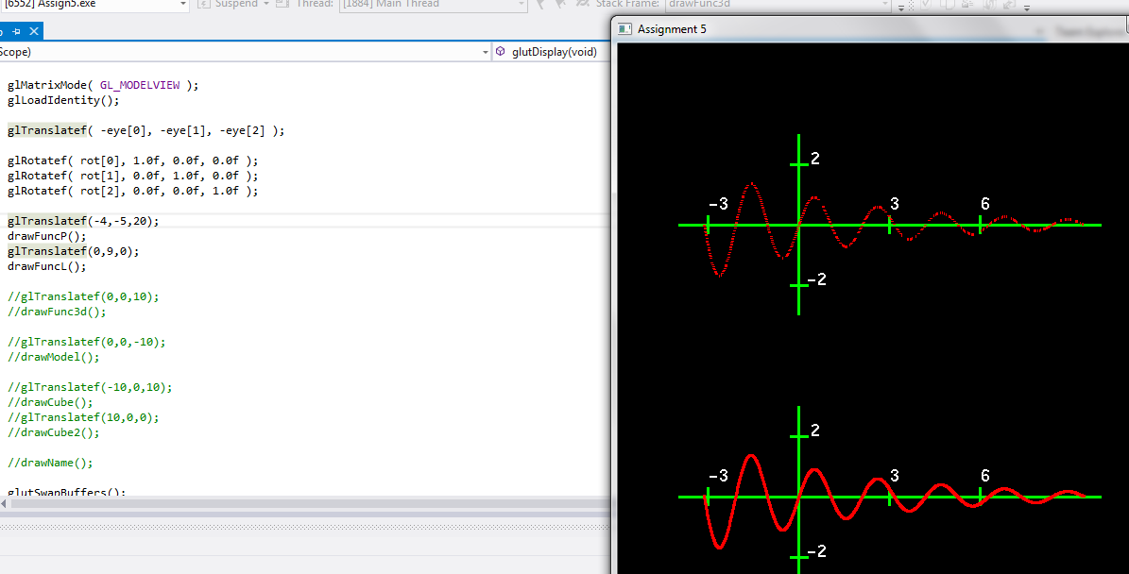

3D plot:

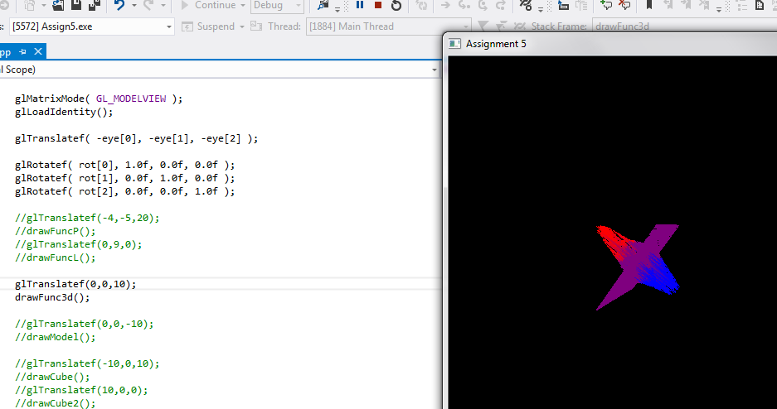

Hallway model:

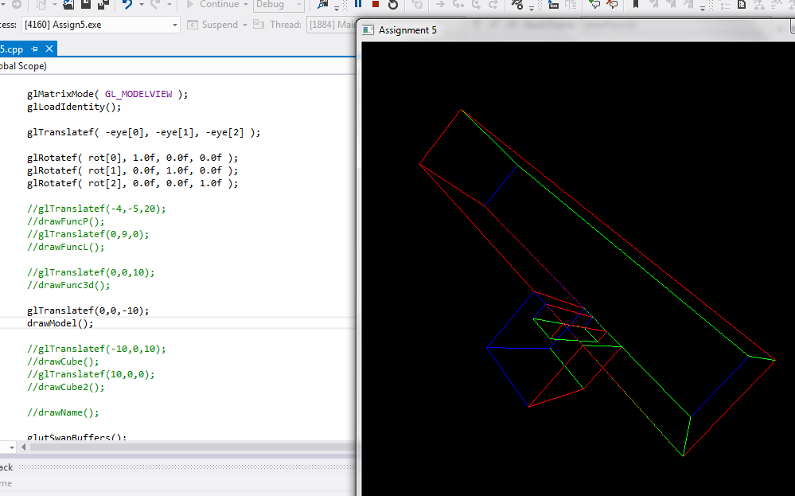

Cubes and name:

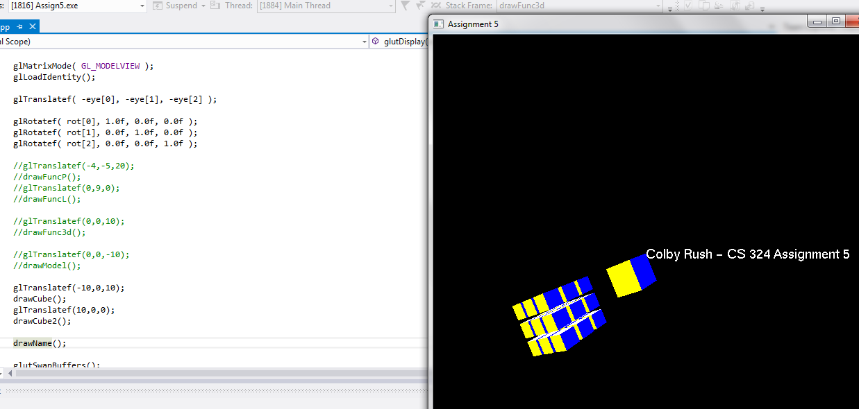

Source code is attached in a separate print out, and as always code can be found at github.com/colbyrush